A SQL Project on Hospital Management System

**Abstract :-**

This project Hospital Management system includes registration of patients, storing their details into the system. The software has the facility to give a unique id for every patient and stores the clinical details of every patient and hospital tests done automatically. It includes a search facility to know the current status of each patient. User can search details of a patient using the id. The Hospital Management System can be entered using a username and password. It is accessible either by an administrator or receptionist. Only they can add data into the database. The data can be retrieved easily. The interface is very user-friendly. The data are well protected for personal use and makes the data processing very fast.

**Objective : -**

1. The Hospital will be able to easily track the details of patients, employees, and other staff of the hospital.
2. It will give a proper relation regarding which staff are working in which patients.
3. It will give details regarding how many raw staffs are being allocated to each patient.
4. It will help in tracking the patients, doctors and other staffs linked to each hospital or patients etc.

**E-R Diagram for Hospital Management system –**

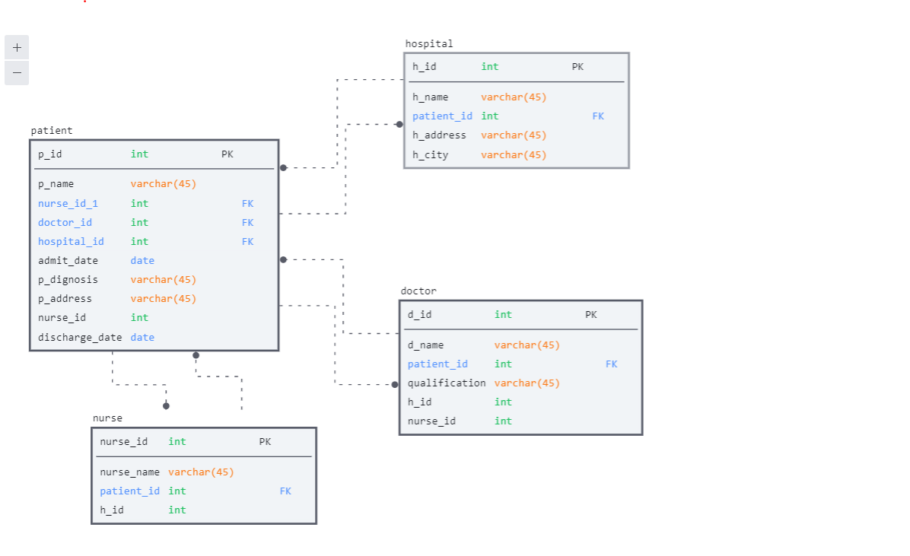

**A- Creating table to store the details of the Patient -**

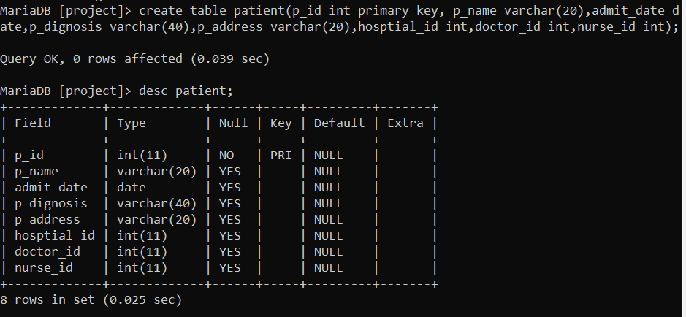

**B- Inserting data of each patient in the patient table.**

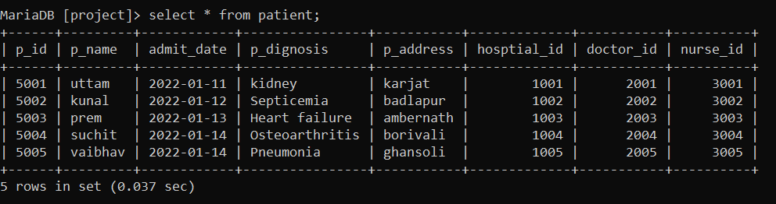

**A - Creating table to store the details of Hospital**

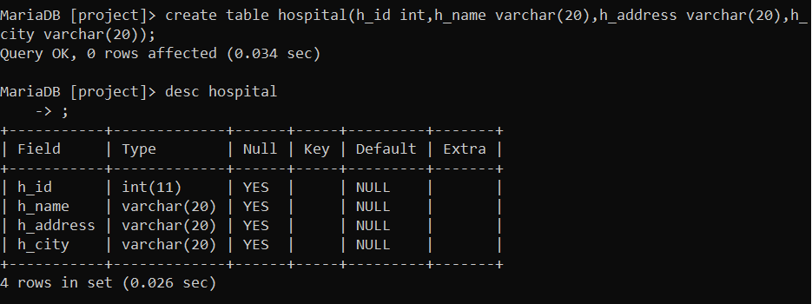

**B- Inserting data in the Hospital table**

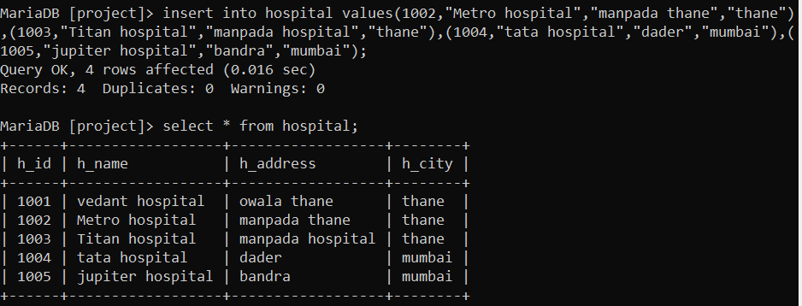

**A - Creating table to store the details of Doctor**

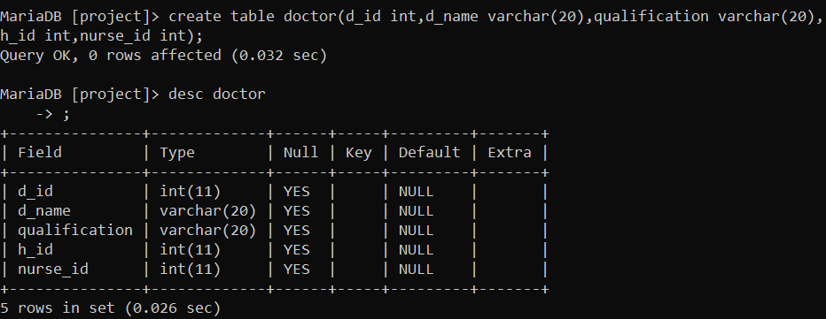

**B- Inserting data in the Doctor table**

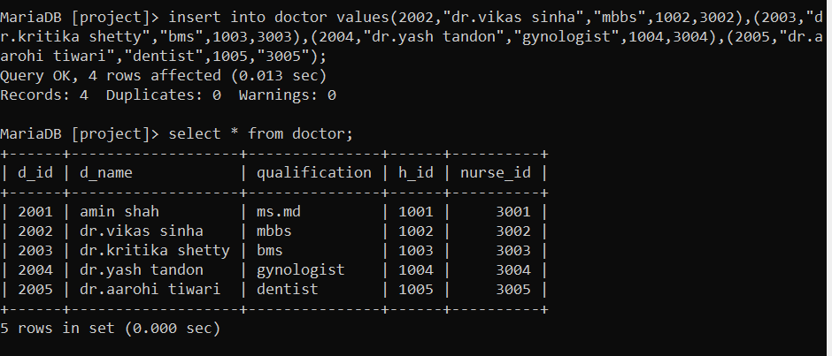

**A - Creating table to store the details of Nurse**

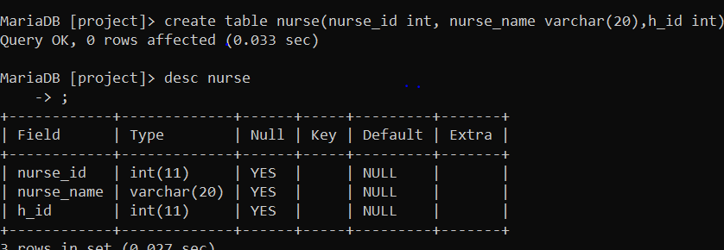

**B- Inserting data in the Nurse table**

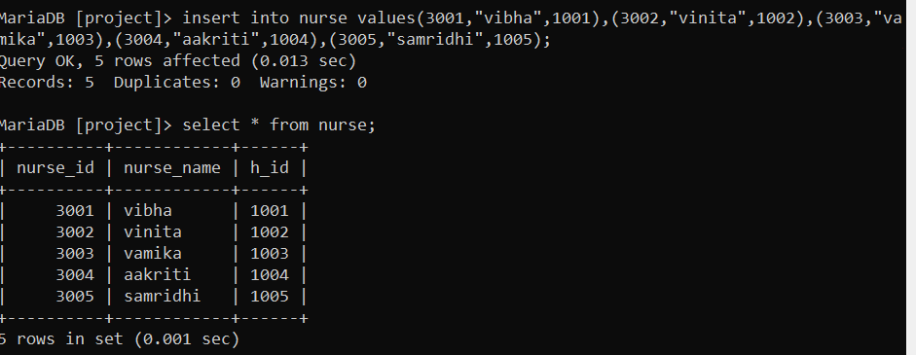

1. **Alter table query is used to add more column in the patient column.**

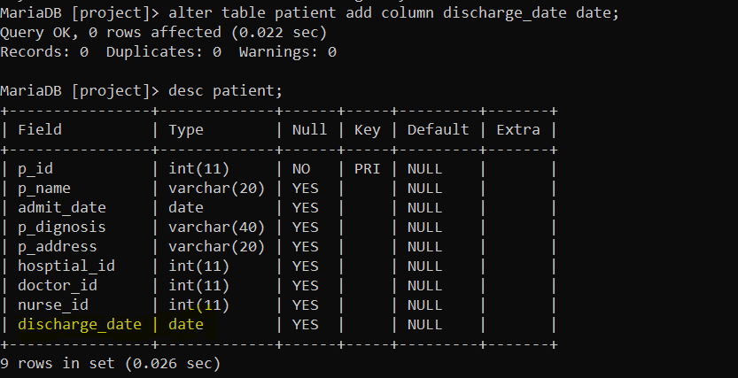

1. **Update table Query to update the data on new table created.**

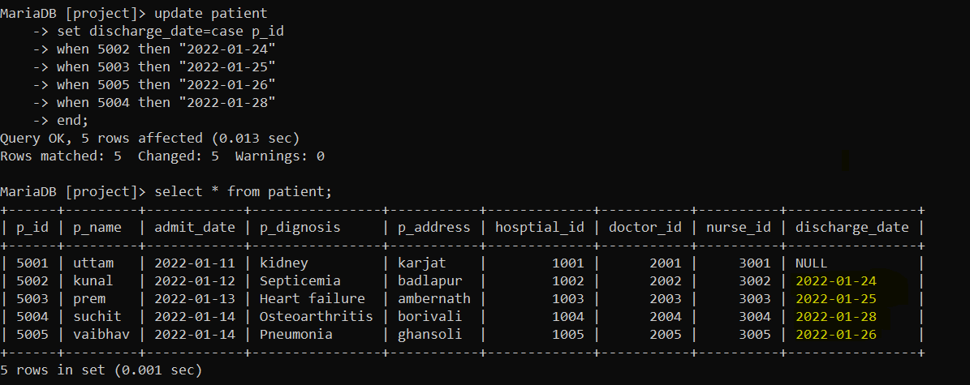

1. **Modifying Query to add primary key to the existing column.**

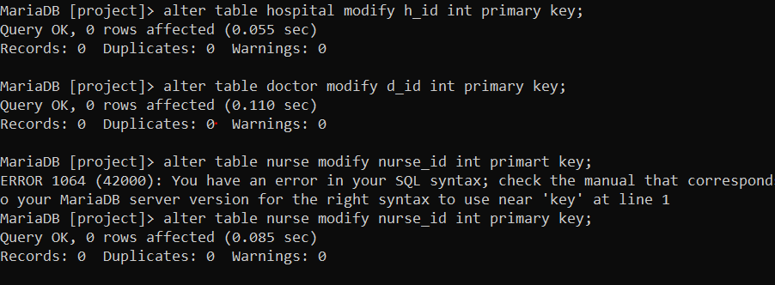

**After modifying**

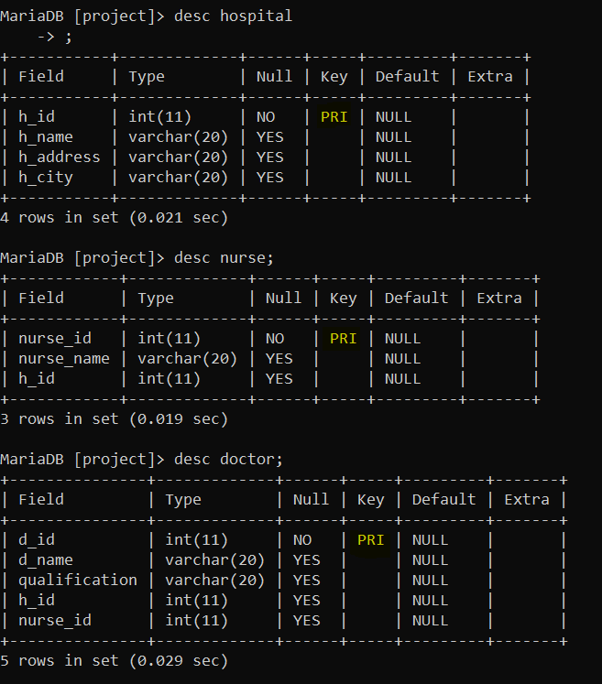

1. **Limit query to show the data up to specified limit.**

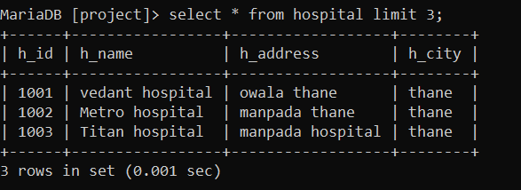

1. **Inner Join query to get the details in single column if specified condition is matched.**

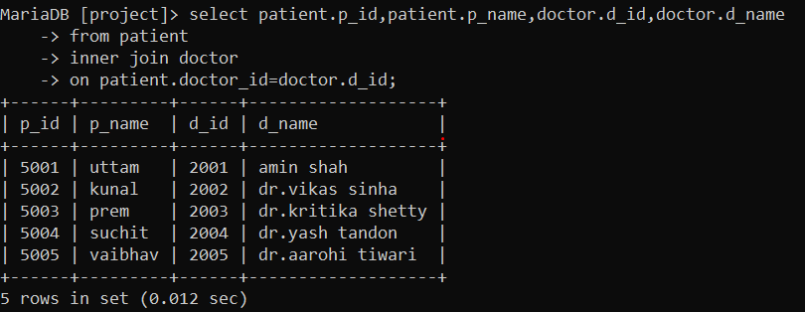

1. **Right Join query to get the details in single column if specified condition is matched.**

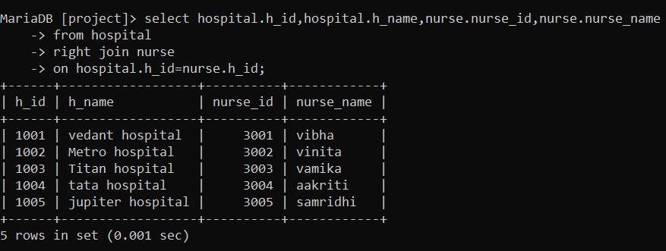

1. **Sub query**

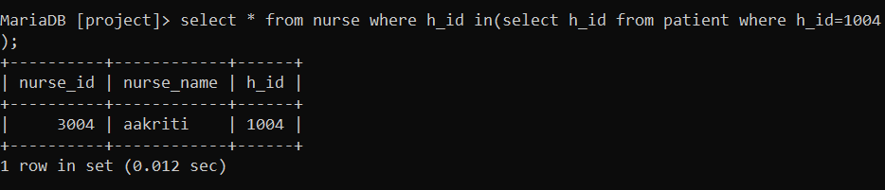

1. **Created table using view.**

